BusinessPLUS
(Version 7.9.10)

Approver
Training Guide

06.05.2019

This page was left blank intentionally.

Approver - Training Guide
Table of Contents
Dashboard Navigation 2
Navigation Bar Icons 2
Keyboard Commands 2
Selection Criteria 2
Purchase Order Life Cycle 3
Purchase Order Types 3
Workflow Approvals 4
1. Approval from: Email Approvals 4
Workflow Approval Options 5
2. Approvals from: Enter Purchase Requests – POUPPR screen 6
3. Approvals from: Workflow Task list 7
Workflow Considerations 9
Reports 10
REPORT: OSGL6004: Budget to Actual by Fund-Responsibility 10
REPORT: OSPO5010: Open PO by Responsibility Code 11

Dashboard Navigation

Navigation Bar Icons
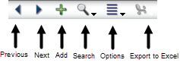

Keyboard Commands
CTRL + A Add a record.
CTRL + D Delete a record.
CNTL + C Copy a record.
CNTL + V Paste a record.
CTRL + F Find/ Search and then Apply Search.
CTRL + G Toggle to and from the grid view and single record view.
CTRL + L View the list box attached to a field with an arrow.
CTRL + T Display the last used auto-generated seed value for a field.
CTRL + N Move to the next record.
CTRL + P Move to the previous record.
CTRL +; Inserts the current date in a date field.
CTRL + 1, 2, 3, etc. Move to another tabbed page on a screen.
(Example: if there are four tabbed pages, press CTRL +3 to move to the third page from the left.)
F1 Display the help file associated with the screen you are viewing.
F5 Refreshes the screen.
ESC Cancel all changes to the record you are working on (since last “ENTER”)
TAB Move through the fields on a screen.
Shift + TAB Move backwards through the fields on the screen.

Selection Criteria
- Recommend using all upper case when entering alphabetic information-some fields are case-sensitive
- Use ‘:’ to specify a range
- Both the ‘%’ and the ‘*’ can be used as wildcards
- Use ‘>’ for greater than
- Use ‘<’ for less than
- Use ‘>=’ for greater than or equal to
- Use ‘<=’ for less than or equal to
- Use ‘<>’ for not equal to
- Use ‘,’ or ‘|’ to specify an OR condition (A,B would be A or B)
- Use ‘=xxx,xxx’ to select text with commas

Purchase Order Life Cycle
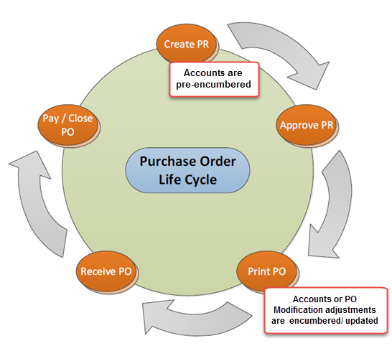

Purchase Order Types
There are two types of Purchase Orders that can be created through the POUPPR screen, an itemized standard PO and a Blanket PO.
- Standard PO – An Itemized PO is the standard PO type. It lists an itemized description of goods, price & quantity of each item. These PO’s are quantity driven and require receiving as BusinessPlus uses three way matching (PO item, received item and AP invoice item). Invoices do not route for approvals.

2. Blanket PO - Blanket PO’s are used when the order is not itemized and is based on dollar amounts. The most common type of Blanket is used to encumber money for services or supplies to be procured from the vendor throughout the school year (e.g. supplies needed by Maintenance Dept.). These PO’s are dollar driven and multiple payments can be made throughout the year. Instead of three way matching, invoices for blanket PO’s are routed for approval (usually same routing as the initial PO). .
NOTE:
PR Request Date: Used to determine which budget year to check for available funds.
PO Print Date: Will update the encumbrance database by dis-encumbering the pre-encumbrance and creating the encumbrance in the budget year indicated by this date.

Workflow Approvals
Definition of Workflow: An automated approval process that is initiated by the creator and sent through to the appropriate approvers based on Purchase Request criteria and system workflow structure.
There are three methods that may be used to approve or reject a Purchase Request (PR). Approvals may be applied (see below for instructions for each method):
- From an email response
- In BusinessPlus directly from the Purchase Request Entry screen - POUPPR
- In BusinessPlus from the Workflow Task list on the Home page
Regardless of where approvals are being applied, it is always important to closely review what is being purchased, from which vendor, how much is being spent and to which account are the goods being charged.

Approval from: Email Approvals
Emails will be sent to approvers and they can simply reply with:
To Approve: Y, YES or OK
To Reject: N or NO
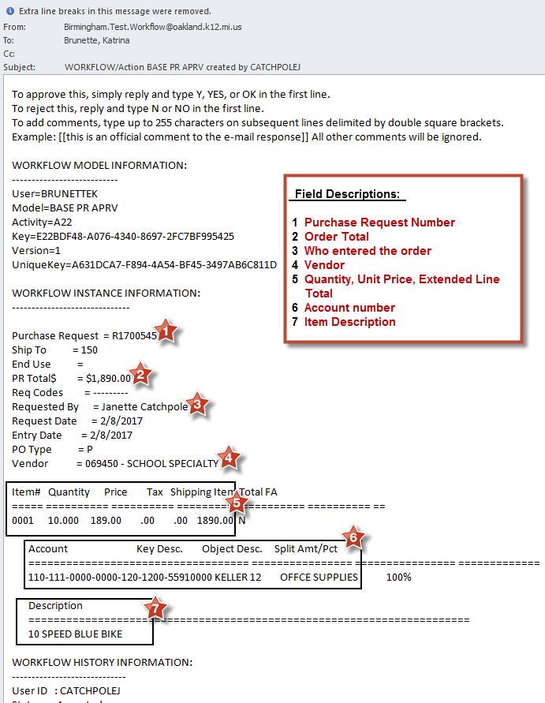

Workflow Approval Options
When approving Purchase Requests in BusinessPlus, there are four options to select from when reviewing records (purchase requests, etc.) in BusinesPlus:
The green check mark will approve the Purchase Request
The red X will reject the Purchase Request
The white hand will place the record on hold indefinitely
The blue arrow will forward the Purchase Request to another user for them to approve.
NOTE: The blue forward arrow can be used in two ways:
- To REASSIGN (or replace) the approval to another person, or
- To obtain an ADDITIONAL approval; will route back to person that delegated for approval
To REASSIGN the PR to another approver:
- Click the Reassignment Only Box (see #1 in screen shot below)
- Select the Delegatee (#2 in screen shot below)
- Enter any Comments for the approver (in the Text Box)
To obtain an ADDITIONAL approval:
- Select the approver from the Delegatee list (#2 in screen shot below)
- Enter any Comments for the approver (in the Text Box)
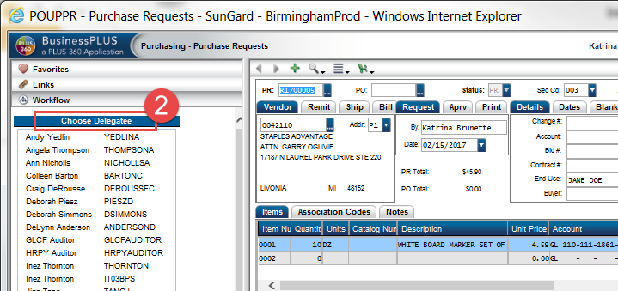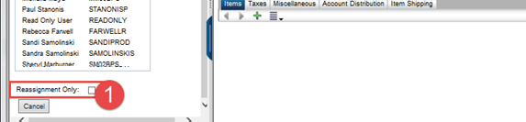

After selecting one of these options it is necessary to click the Submit button. There is a text box available to include any comments.

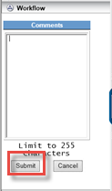
NOTE: It is recommended to use the Comments box if a PR has been rejected to let the Creator know why and to provide further instructions, if any.

Approvals from: Enter Purchase Requests – POUPPR screen
Approve by accessing POUPPR from the link on the Schools/Departments tab.
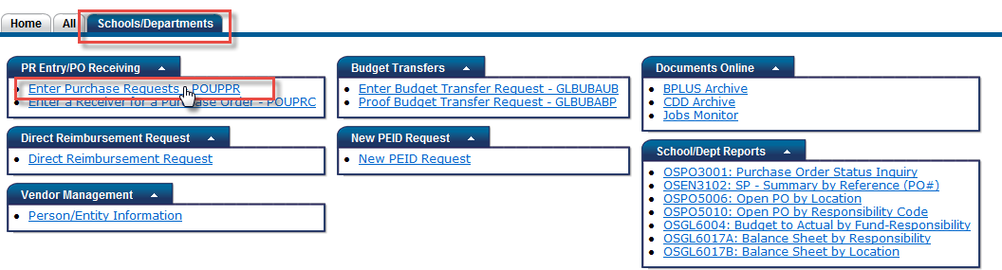

Click on Workflow located on the side options menu.
A list of Purchase Requests requiring approval will display under the Direct Task Items Awaiting ID Approval heading. These are all Purchase Requests awaiting the User’s approval. 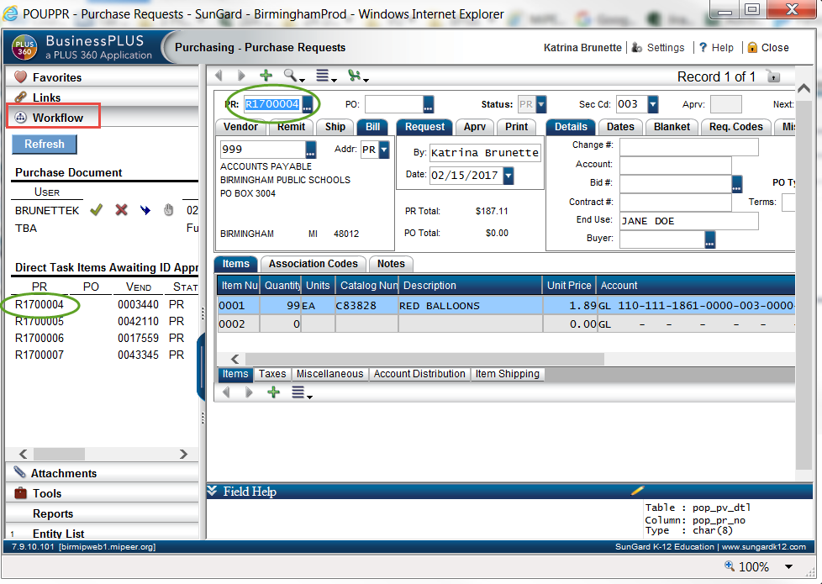
The Purchase Request(s) can be viewed by double-clicking on the PR number. The system will then display the Purchase Request on the data entry portion of the screen.
Purchase Requests must be reviewed and approved one by one from this screen.
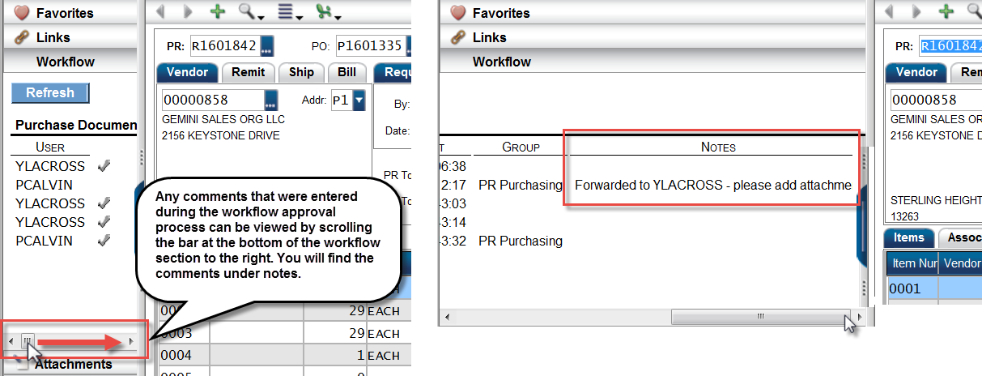

Approvals from: Workflow Task list
Approvals may also be given through a task list accessed from the Home page of the Dashboard.
To approve Purchase Request’s, double-click on the ‘PR Approval’ link to access the task list window. A list of pending PR’s will display by Entry User ID.
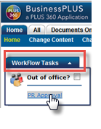
Select the Purchase Request to review by clicking on the PR number on the list. The system will display details about the selected Purchase Request to the right and also show the approval history located on the top right. The user may then approve, reject or forward the Purchase Request by using the check mark, red x or blue arrow on either the left panel at the bottom or above the Request Summary.

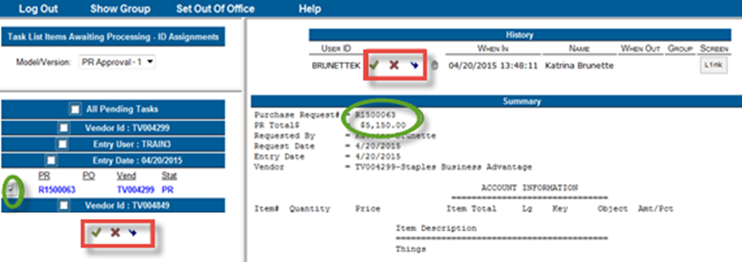
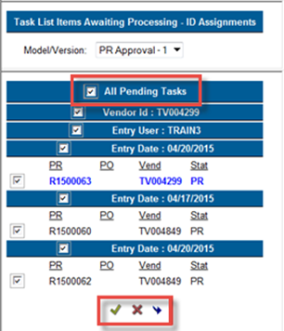
It is possible to approve multiple Purchase Requests at once (after previously reviewing them) by checking the box All Pending Tasks on the list and using the green check mark at the bottom of the list. The Purchase Requests are not approved until the Submit button is clicked.
NOTE: Any text entered in the Comments box will be viewable for all PR’s selected for approval or rejection.

After the PR’s are approved or rejected, a message will indicate the number of PR’s that were successfully processed.
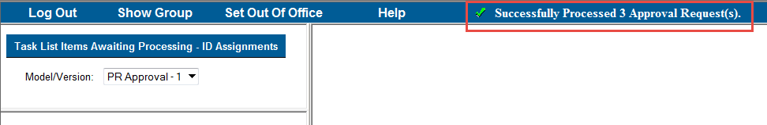
To return BusinessPLUS, click the X to close out the page and you will be returned to the Home dashboard.
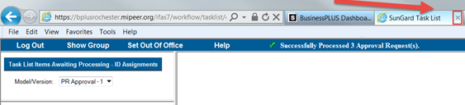

Workflow Considerations

Rejected PR’s
When a PR is rejected, an email is sent to the creator of the PR. It is necessary for the creator to make the appropriate changes to the PR in the POUPPR screen and re-submit through the workflow process.

Reports
The Schools/Departments dashboard has a report section that includes frequently run reports.

REPORT: OSGL6004: Budget to Actual by Fund-Responsibility
This report displays account budget, encumbrances, actual expenses and the balance. Additional details can be accessed by drilling down in the report (look for a drill as the cursor moves across the report).
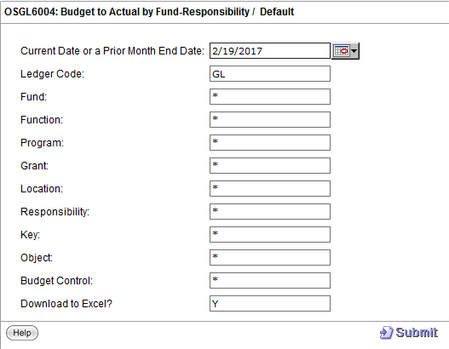
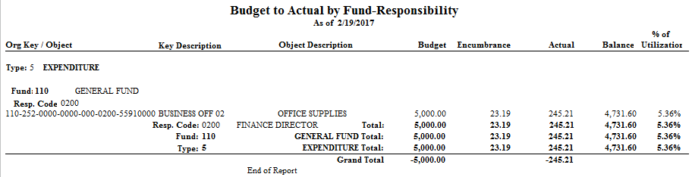

REPORT: OSPO5010: Open PO by Responsibility Code
This report will show all open purchase orders by Responsibility Code. This report defaults to allow the user to export the data to Excel. If exporting to Excel is not desired, change the Y to N.
Enter a Responsibility Code to run the report on. Click Submit.
